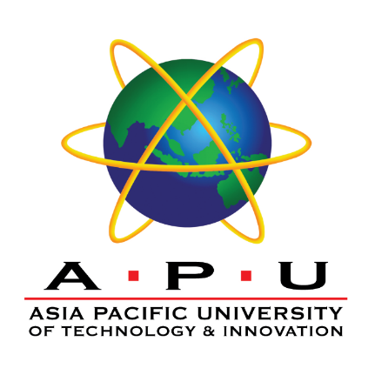

**INDIVIDUAL ASSIGNMENT**

**TECHNOLOGY PARK MALAYSIA**

**CT071-3-3-DDAC**

**DESIGNING AND DEVELOPING**

**APPLICATIONS ON THE CLOUD**

**UC3F1706SE**

**HAND OUT DATE: 11 DECEMBER 2017**

**HAND IN DATE: 13 APRIL 2018**

**WEIGHTAGE: 100%**

**INSTRUCTIONS TO CANDIDATES**

1. **Students are advised to underpin their answer with the use of references (cited using the Harvard Name System of Referencing).**
2. **Late submission will be awarded zero (0) unless Extenuating Circumstances (EC) is upheld.**
3. **Cases of plagiarism will be penalized.**
4. **The assignment should be bound in an appropriate style (comb bound or stapled)**
5. **Where the assignment should be submitted in both hardcopy and softcopy, the softcopy of the written assignment and source code (where appropriate) should be on a CD in an envelope / CD cover and attached to the hardcopy.**